**COAL LAB 6**

**Question 1**

INCLUDE Irvine32.inc

.data

str1 BYTE "Generating 20 random integers between 0 and 990",0

.code

MAIN PROC

mov eax, black + (green*16)

call SetTextColor

call crlf

call clrscr

mov edx,OFFSET str1

call writeString

call crlf

mov eax,991

mov ecx,20

mov edx,0

inc dh

loop1:

call Gotoxy

call RandomRange

call WriteDec

mov eax,5

call delay

mov eax,991

call crlf

add dh,1

add dl,2

loop loop1

exit

MAIN ENDP

END MAIN

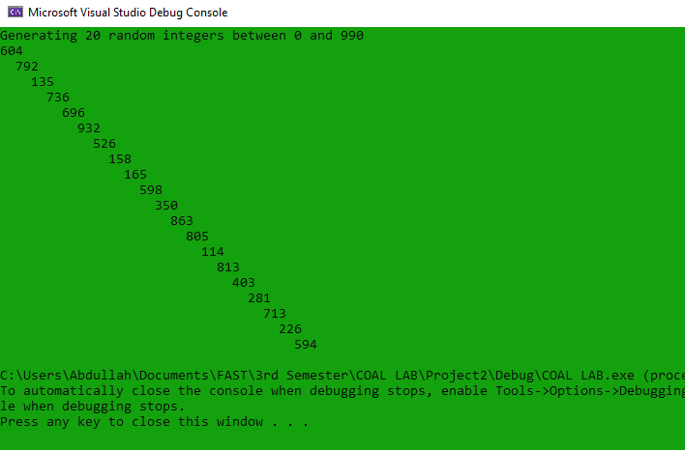

**Question 2**

INCLUDE Irvine32.inc

.data

char BYTE "F",0

row BYTE ?

col BYTE ?

.code

MAIN PROC

mov ecx,100

mov edx,0

target:

mov eax,24

call RandomRange

mov row,al

mov eax,79

call RandomRange

mov col,al

mov dh,row

mov dl,col

call Gotoxy

mov edx, OFFSET char

call WriteString

mov eax,100

call delay

loop target

call GetMaxXY

call GotoXY

exit

MAIN ENDP

END MAIN

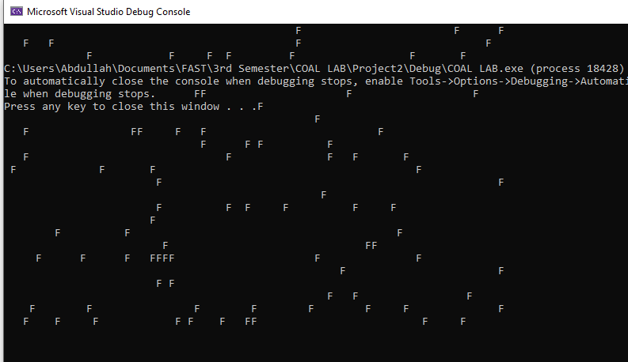

**Question 3**

INCLUDE Irvine32.inc

.data

str1 BYTE "Unsigned Numbers: ",0

str2 BYTE "Signed Numbers: ",0

gap BYTE " ",0

.code

MAIN PROC

mov ecx,10

mov edx, OFFSET str1

call writeString

unsigned:

mov eax, +4294967294

call RandomRange

call WriteDec

mov edx,OFFSET gap

call WriteString

loop unsigned

call crlf

mov ecx, 10

mov edx,OFFSET str2

call writeString

signed:

mov eax,+100

call RandomRange

sub eax, 50

call WriteInt

mov edx, OFFSET gap

call WriteString

loop signed

exit

MAIN ENDP

END MAIN

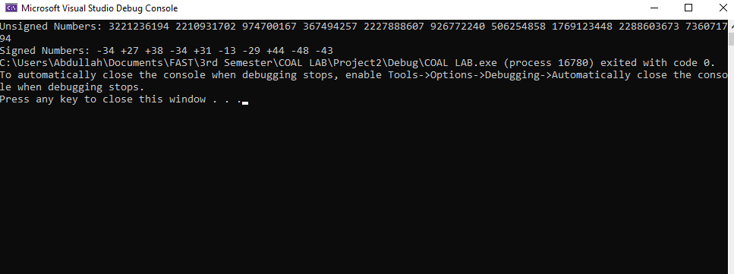

**Question 4**

INCLUDE Irvine32.inc

.data

fileName BYTE "Question4.txt",0

fileHandle HANDLE ?

str1 BYTE "Sir Please accept my late submission. ",0

str2 BYTE "File Created Successfully",0

.code

MAIN PROC

mov edx, OFFSET fileName

call createOutputFile

mov fileHandle,eax

mov edx,OFFSET str1

mov ecx, LENGTHOF str1

call WriteToFile

call CloseFile

mov edx, OFFSET str2

call WriteString

exit

MAIN ENDP

END MAIN

